Prompt Engineering Techniques
Objective
To understand and demonstrate different Prompt Engineering techniques used to improve the quality, accuracy, and relevance of responses generated by Large Language Models
1. Zero-Shot Prompting
Definition
Zero-Shot Prompting is a technique where the model is given a task without any examples. The model relies solely on its pre-trained knowledge to generate a response.
Example Prompt
Summarize the following article in 100 words.
Observation
The model generates a summary based on its understanding of the instruction without needing sample outputs.
Screenshot


2. Few-Shot Prompting
Definition
Few-Shot Prompting provides one or more examples before presenting the actual task. These examples guide the model in understanding the expected format and response style.
Example Prompt
Input: I loved the movie.
Sentiment: Positive
Input: The service was terrible.
Sentiment: Negative
Input: The food was amazing.
Sentiment:
Output
Positive
Observation
The examples help the model recognize patterns and improve prediction accuracy.
Screenshot
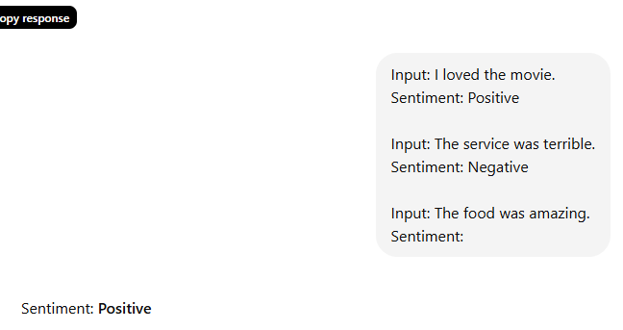

3. Role Prompting (Role Playing)
Definition
Role Prompting assigns a specific role, expertise, or perspective to the AI before giving it a task. This influences the tone, depth, priorities, and decision-making process of the response.
Weak Role Prompt
Prompt
You are a financial analyst.
Analyze this quarterly report.
Observation
The response may be generic because the role lacks context and priorities.
Screenshot
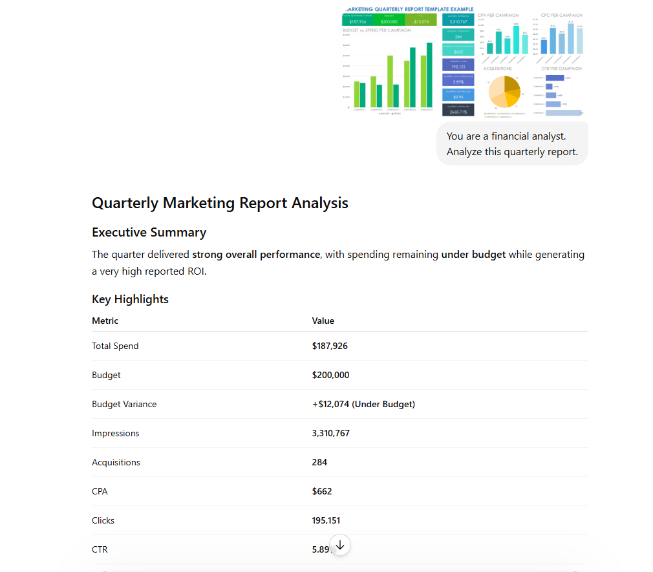
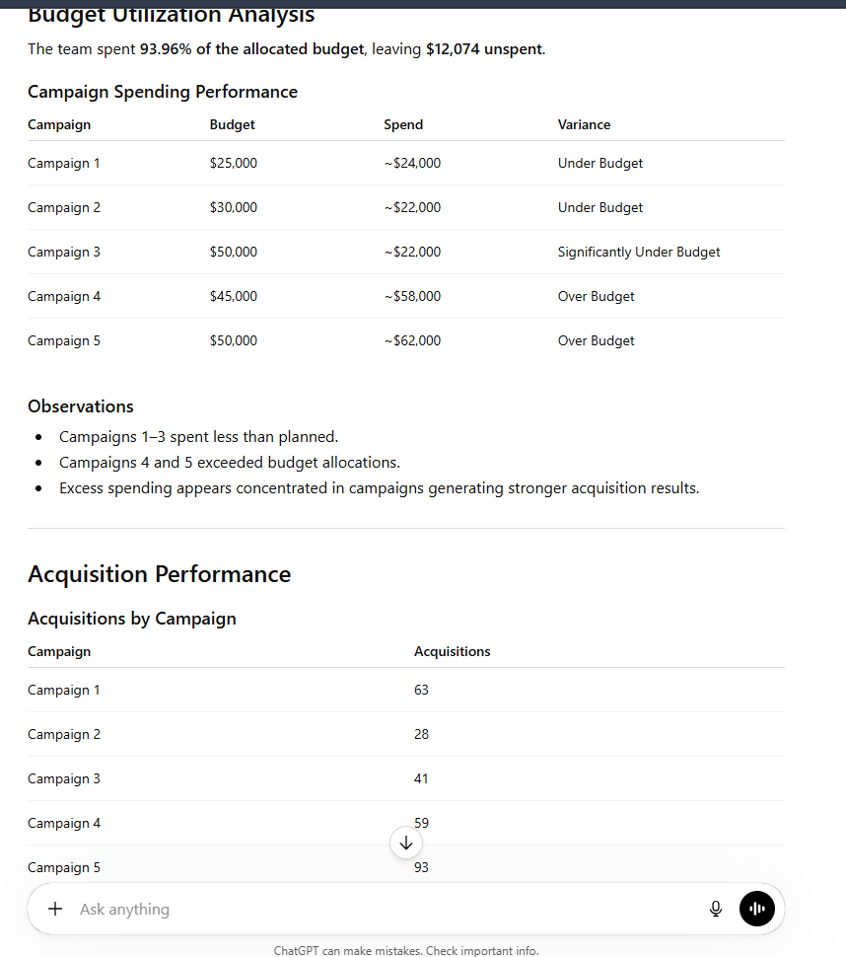

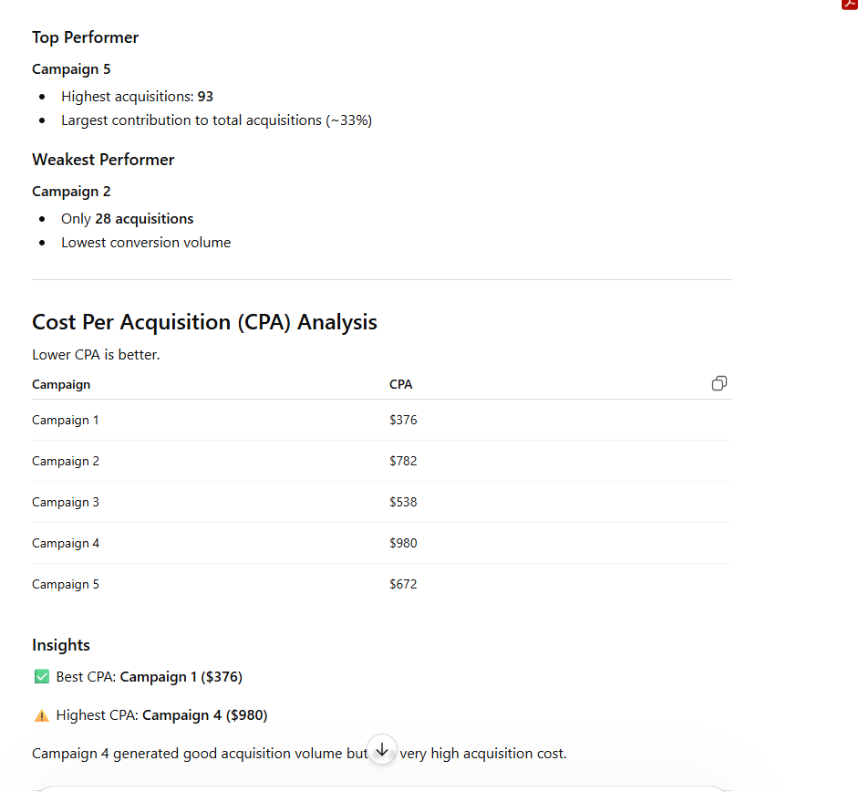

Strong Role Prompt
Prompt
You are a senior financial analyst with 10 years of experience.
You focus on identifying risks, anomalies, and trends that leadership needs to act on, rather than simply reporting numbers.
Analyze the following quarterly report.
Observation
The response becomes more insightful, actionable, and tailored to business decision-makers.
Screenshot
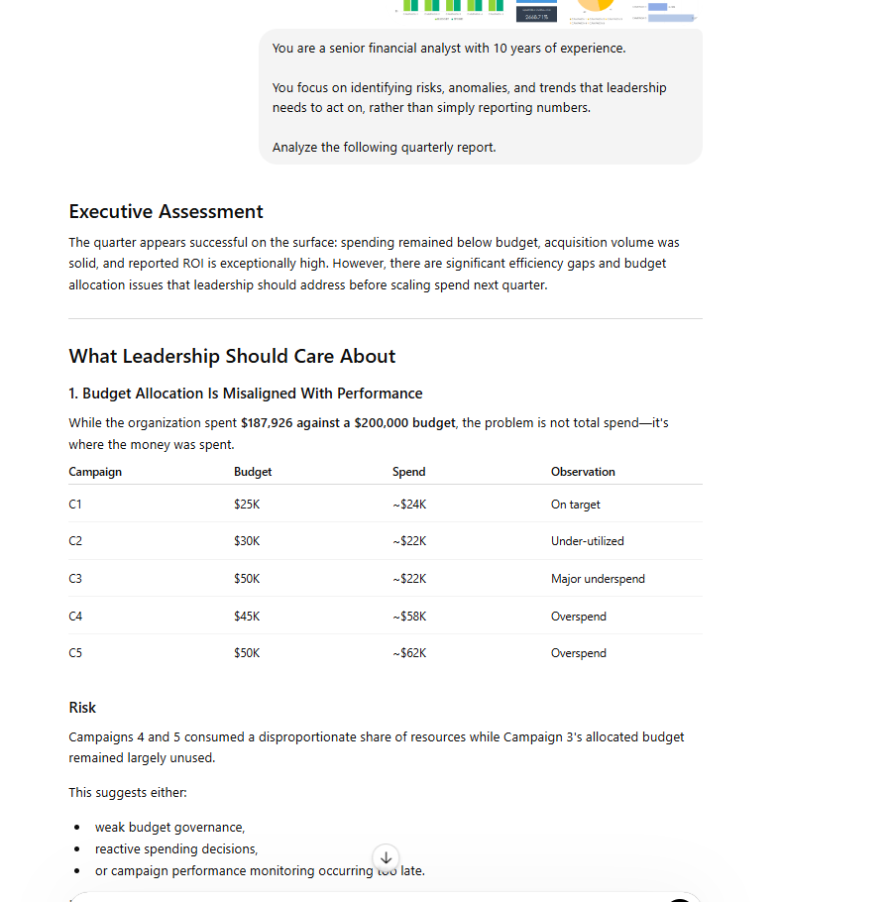

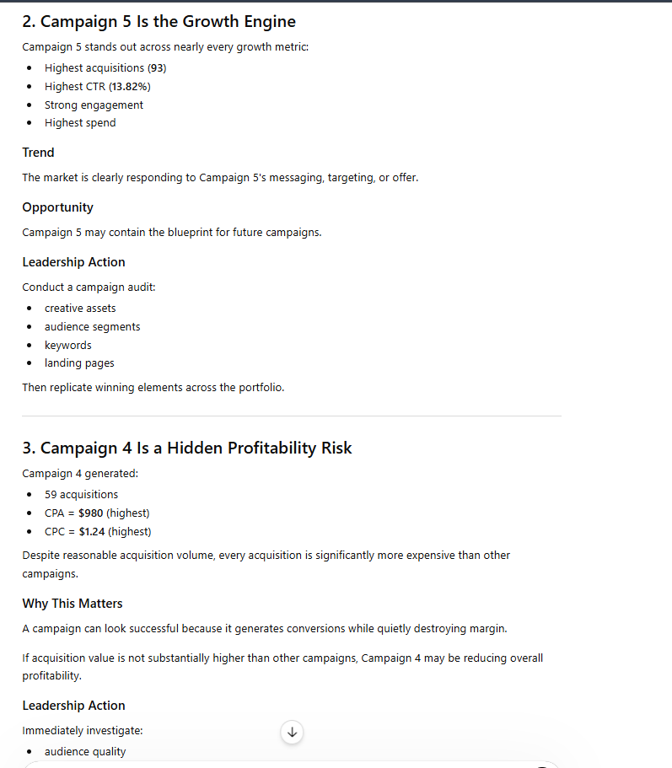

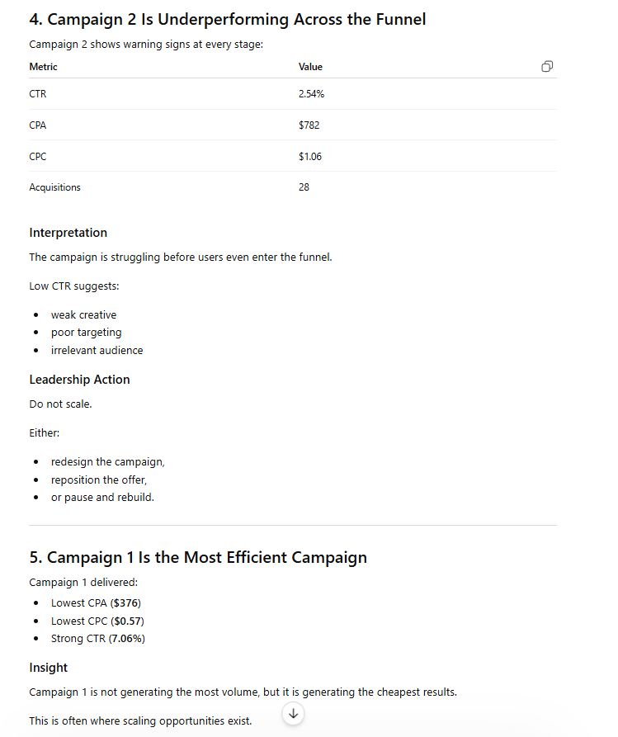

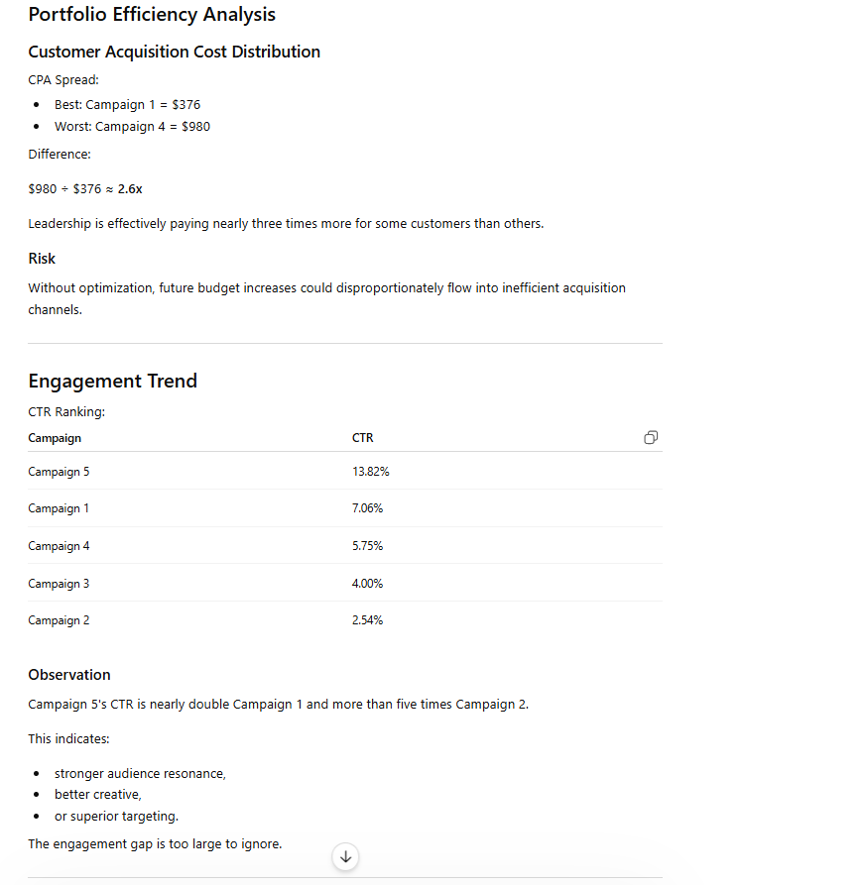
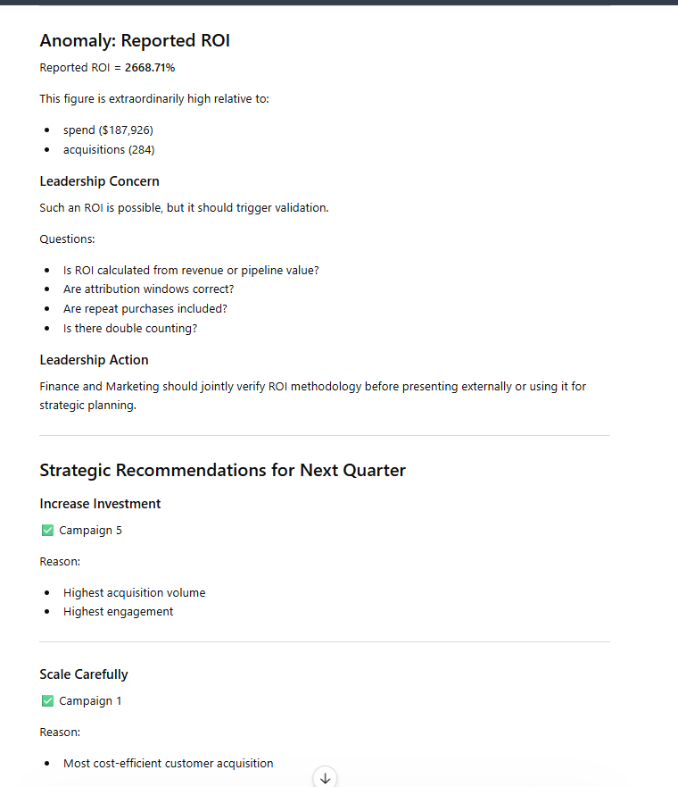

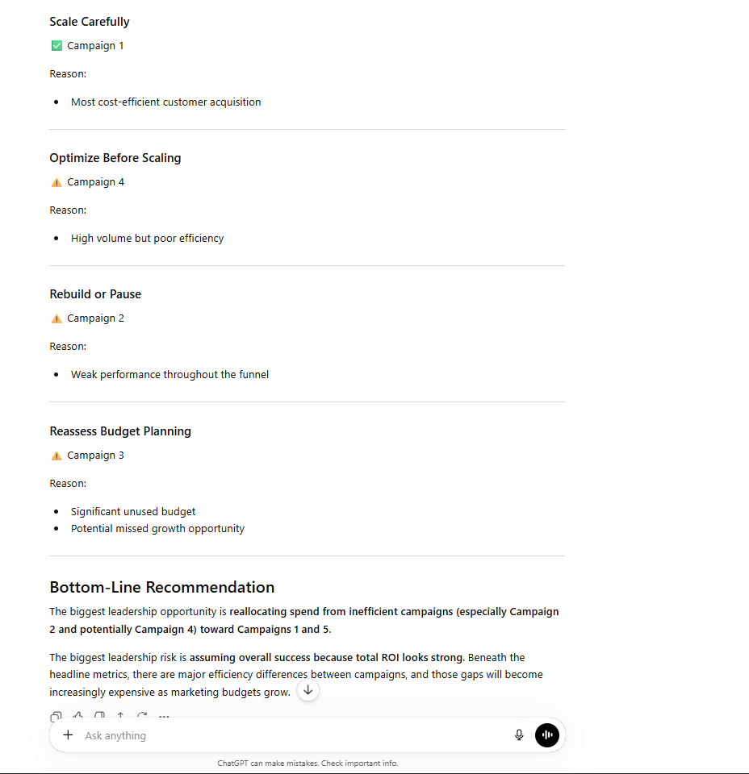
4. Role Prompting for Email Generation
Without Role Prompt
Prompt
Write a cold email to a potential client about our analytics software.
Observation
The email is usually feature-focused and generic.
Screenshot
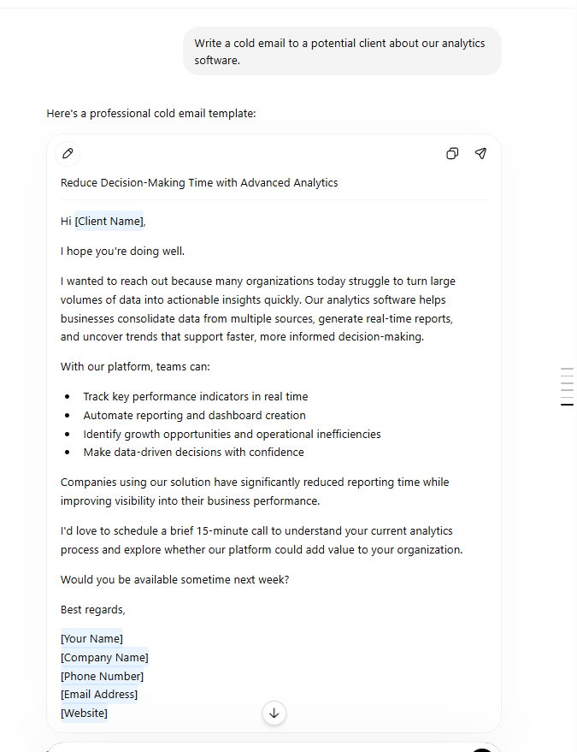

With Role Prompt
Prompt
You are a senior sales representative who has successfully closed more than 200 enterprise deals.
You understand that cold emails succeed when they focus on customer pain points rather than product features.
Write a cold email to a VP of Marketing introducing our analytics software.
Observation
The generated email is more persuasive, customer-centric, and effective.
Screenshot
